**VISVESVARAYA TECHNOLOGICAL UNIVERSITY**

BELAGAVI, KARNATAKA-590014

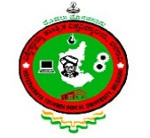

##### DBMS MINI PROJECT REPORT ON

##### **EMPLOYEE MANAGEMENT SYSTEM**

##### 

###### **Submitted by**

**SUNIL ACHAR 4DM16IS043**

**UNDER THE GUIDANCE OF**

**Mrs. SUPRIYA R K B.E.,M.Tech.**

**Assistant Professor , Dept of ISE**

***In partial fulfillment for the award of the degree of***

##### BACHELOR OF ENGINEERING

IN

INFORMATION SCIENCE AND ENGINEERING



### YENEPOYA INSTITUTE OF TECHNOLOGY

N.H.13, Thodar, Vidyanagar, Moodbidri, Mangalore, Karnataka 574225

2018-2019